Ecole Agnes Davidson School

2103 – 20 Street South, Lethbridge, Alberta, T1K 2G7, Phone (403) 328-5153, Fax (403) 320-1912

Principal Terra Leggat Vice Principal Mme Megan Cummins

Dear New Families to École Agnes Davidson,

Welcome to your new school. Below is some information to help you in your transition. Please make yourself familiar with our school website, www.ad.lethsd.ab.ca. It has wealth of information with our newsletters, calendars, parent handbook, bussing, student supply lists and coming events for the year.
- Your child’s first day of school.
- Teachers will email all families on Friday, August 27th with the student’s homeroom.
- First day of the new school year will be a staggered entry. Student’s with surnames A-M will start on August 31st and students with surnames N-Z on September 1st. All students will come on September 2nd. Please join the staff outside in the field and join your teacher in line. We will be saying good-bye to parents outside and then the students and staff will be proceeding into the school.
- Student Attendance - Please make sure your child arrives on time.
All absences, planned late arrivals or planned to leave early, are to be reported by using the School Messenger system:
- Toll Free 1-866-879-1041
- Website, https://go.schoolmessenger.ca.
- School Messenger APP (Free APP from Apple or Google Play stores)
Please Note: All students arriving late or leaving early must always report to the office for either a late slip or to be signed out so the office as updated/current records for safety reasons or in case of an emergency.
- Students with medical alerts, such as epi pens or inhalers, that are to be kept at school, are required to have Lethbridge School Division medical forms filled out and signed by a doctor yearly. All medical alerts will be copied and put in confidential binders in each homeroom. Please speak to the office if you require forms or for more information.
- The Student Handbook can be found on the school website. Please review this with your child as appropriate to ensure you are familiar the schools’ procedures.
- Once Covid protocols allow, we welcome Parent Volunteers. Please connect with your child’s teacher or school council for volunteering opportunities. All volunteers will need to complete a Lethbridge School Division Volunteer form before the volunteering begins. We also have a lovely sign in/out binder and tag system in place for safety reasons or in case of an emergency.

Bell schedule 2021-2022
Grade 1-5 | First  Bell | AM  Start | End  Time
Mon.-Thurs. | 8:30 | 8:35 | 3:32
Fri. | 8:30 | 8:35 | 11:45 - Noon dismissal

Kindergarten | First  Bell | AM  Start | AM  Finish |  | PM  Start | PM  Finish
Mon.-Thurs. AM | 8:30 | 8:35 | 11:47 |  |  |  | + Scheduled Friday’s
Mon – Thurs PM |  |  |  |  | 12:20 | 3:32 | + Scheduled Friday’s
Full Day | 8:30 | 8:35 |  |  |  | 3:32 | + Scheduled Friday’s
École Agnes Davidson Website

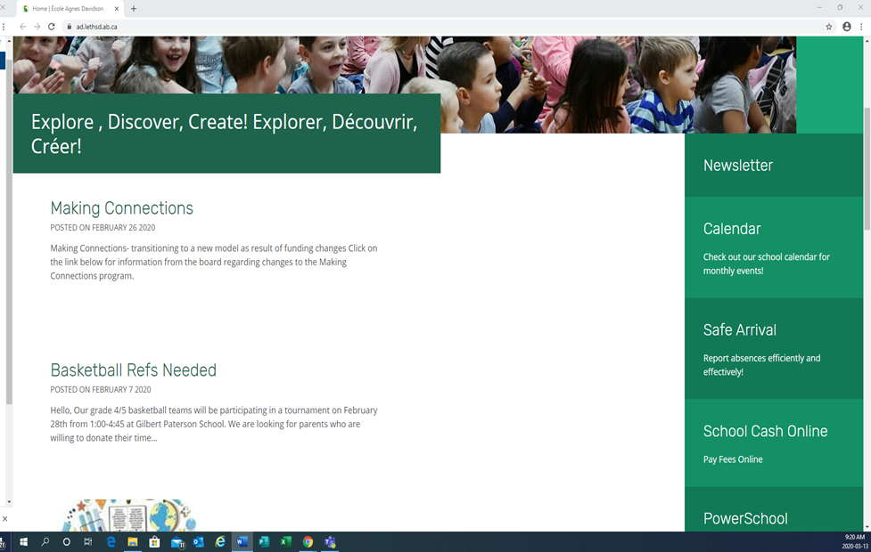
Dear New Parents,
École Agnes Davidson School
is online for your convenience.
Here are the links to our very important
online programs.
Please take a few minutes to register your family so that you will be connected with your new school.
- Safe Arrival, to record any absences, lates or leaving early. There are 3 Options:
- Toll Free 1-866-879-1041 phone number
- A free School Messenger App for your smart phone (from apple or google play store)
- Website http://go.schoolmessenger.ca

- School Cash Online To pay for Agenda & fieldtrip fees, fundraisers, monthly school lunch orders, school swag and Aggies Coffee/Tea etc.
To set up this family account you will need each child’s Alberta ASN number. Found on a previous report card or provided by the school office.
- Power school to view or download report cards. To set up this family account you will need your PS ID information provided by the school.

Thank you!
Student Fees

Fees are due the first week of September.

Throughout the year you will also be invited to participate in several online purchasing events including LOTG (Lunch on the Go) days. Monthly Aggies Brew/Cuppers Coffee/Tea orders. A Kindergarten fee plus fundraiser & more.

Student School Fees
Fees are due in September. Please go to the link on our webpage and make your family account. You will need your child’s ASN (Alberta Student Number) which can be found on an Alberta report card or by calling the school office.

WELCOME TO YOUR NEW
SCHOOL

