École Agnes Davidson School

A Student’s Guide to the Science and Heritage Fair

- École Agnes Davidson School Science and Heritage Fair is held every year in March
- The Fair is open to students in Grades 1 through Grade 5 but only those students in Grade 4 and 5 will be marked and judged and are eligible for entry into the local Science Fair and Heritage Fair. Students in Grades 1 through 3 will present their project to a judge who will provide them feedback on their efforts.
- Science Fair Projects can be in any area of science; Biological Sciences, Physics, Electron- ics, Chemistry, Astronomy, Meteorology, Geology, Geography, Geophysics, Computing or Mathematics.
- Heritage Fair Projects must represent Canada in some capacity. Areas of study could in- clude; important moments in history, Canadian inventions, Canadian people, Canada and the world, etc.
- Projects should contain an element of original research.

1st Step—Coming up with ideas
Knowing where to start is perhaps the most difficult step. Here are a few ideas;
- Start with a real-life problem that you have. What do you find annoying in your daily life? For example;
  - The supermarket doesn’t have a tasty gluten-free ice cream—You could make your own recipe of a tasty ice-cream.
  - My sister always recalls the wrong thing—You could start an experiment testing the reliability of people’s memories and come up with ways to remember better.
- Or, start with a question that you want to answer, something that interests you, makes you
wonder. The question can be about microbiology, maths, chemistry, etc. For example;
  - Is Vitamin C really good for you.
  - Which product works the best.
- Or, chose a topic that you would like to learn more about. For example;
  - an animal, a person, the stars, how something is made, a famous event, etc.
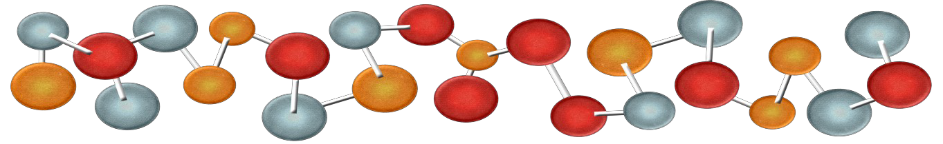

Before choosing an idea from your brainstorm, you need to be aware of three different cate- gories—your ideas should fall into one of these;
- Experimental Research: a project that involves a controlled experiment
E.g. Which brand of battery lasts the longest?
- Technological Development: this is where your idea involves creating or designing some- thing to help people or make life easier
E.g. Inventing a new, more user-friendly mailbox.
- Research to increase your knowledge of a Scientific or Canadian Heritage topic; this is where your idea is tested by gathering and analyzing data and information and presenting what you have learned about the topic

After you have brainstormed some ideas, look at each of them and ask yourself;
- Does my idea fall into one of the Scientific categories or the Heritage category?
- If I need to do an experiment, can I design a method that is feasible?
- Can I finish the project within a few months, in order to meet the deadline?
- If I have to buy equipment to do the project, do I have support to do this from my par-
ents?
- Is the project appropriate for my grade?
- Will I really enjoy doing this project?

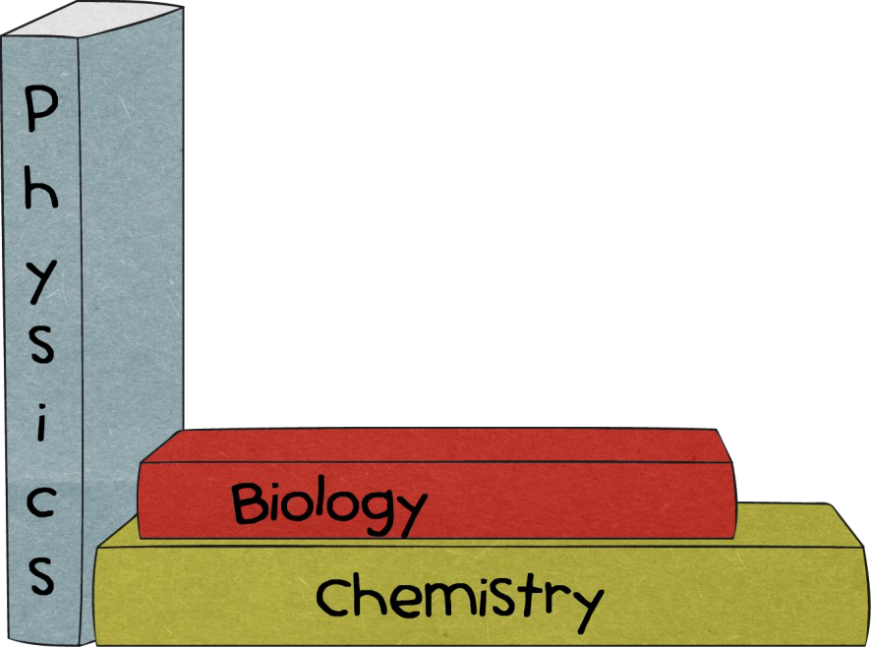
You can browse the net, discuss with your teachers, parents, and friends and seek advice from experts. When the answer is “yes” to all six questions and you are satisfied with your idea, then use that topic for your project.

Logbook
Research
Aim
Hypothesis
Equipment
Method
Results
Discussion
Conclusion
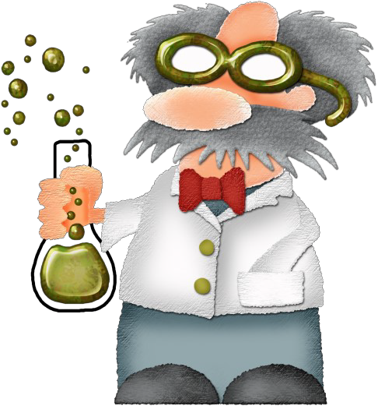

*Get a notebook—an ordinary exercise book will be fine
*Start making notes of everything you do, find out, think…
*It will be important to share your logbook with judges

EXPERIMENTAL RESEARCH
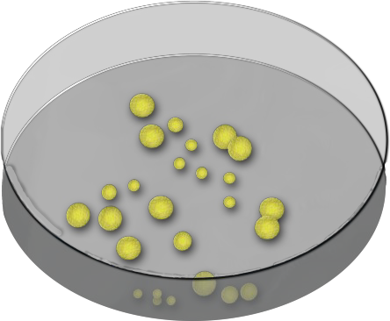
*Do some background research on the topic
*Find out what others have done
*Use the research as the basis for your questions
*What do you want to find out?
*Why do you want to do the experiment?
*What do you think will happen?
*Make an educated guess from the background research you have done
*Find out and list all the equipment and resources you need
*Also list all the independent, dependent, and controlled variables
*Give the instructions for your experiments clearly and concisely and in order, so that someone else can repeat it
*Number each step, and begin each step with a verb, e.g. place, mix, cut, etc.
*Record all the raw data in a table. Include samples, photos, diagrams, etc. where appropriate
*Process the data—often a fully labelled graph is an excellent, visual way
*Discuss the difficulties you’ve encountered and how you can do better next time
*Was you hypothesis right? Why?
*Do you have any theories to explain the data and the hypothesis?
*Have you learned anything?

Logbook
Problem
Research
Solution
Testing
Discussion
Market
*Come up with creative ideas for production, packaging and marketing
*Has your development been successful?
*Discuss the application of your solution. Will others find it useful?
*Try your solution with a sample of people
*Ask for feedback and keep making improvements until you’re satisfied
*Again, keep a record of all the testing
*Start with a drawing/model, then build a series of prototypes
*Carry out appropriate tests, performance measurements, etc.
*Find out what others have done about the identical problem
*Find out about the cost of equipment and resources
*Start with a need or opportunity
*Are you improving existing technology or designing a technological innovation? Think about how it would benefit certain groups of people
*Get a notebook—an ordinary exercise book will be fine
*Start making notes of everything you do, find out, think…
* It will be important to share your logbook with judges

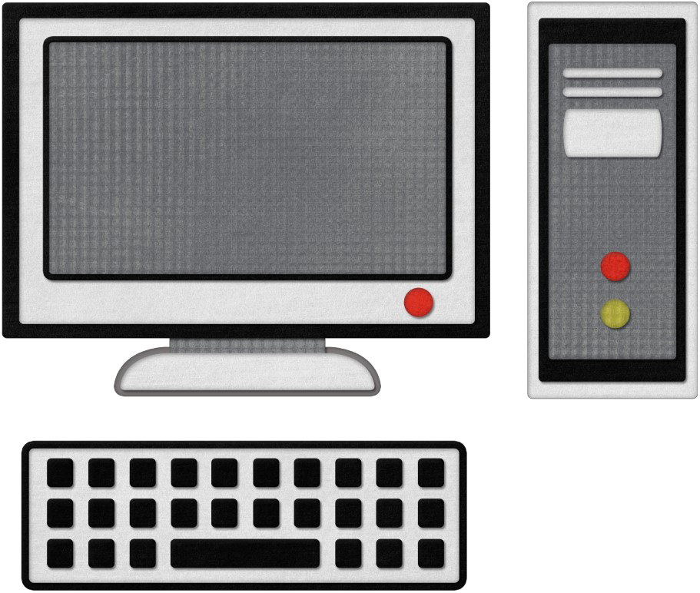

Logbook
*Get a notebook—an ordinary exercise book will be fine
*Start making notes of everything you do, find out, think…
* It will be important to share your logbook with judges

Research
*Give the reader some background information to your topic and reasons why you choose this area of research

Plan
*List key questions
*Identify possible resources

Collect
*Collect relevant information from a range of sources, e.g. books, multimedia, surveys, people, websites, etc.

Process
*Organize and evaluate selected information on the topic
*Summarize your research findings
*Select relevant and useful illustrations, diagrams, graphs, and artifacts

Interpret
*Think about what the selected information means in terms of your research topic

Discussion
*Did you encounter any problems during your research?
*Is so, how can you improve next time?

Report
*Write the final draft of the report
*The final report can include illustrations, graphs, models, etc.
*Include a full list of references of resources used

Conclusion
*Make generalizations and form judgements
*Have you answered all the key questions in your plan?

At the École Agnes Davidson School Science and Heritage Fair, you will need to display your project on a board. Most stationary shops, including Micheals, Walmart, Dollar Stores, and Staples, sell these. Be creative as you can when putting the information on the board. Include pictures, charts, diagrams, and you can even put your model or a small demonstration in front of the board.
To give you an idea of how to start, have a look at the board below and see how different sec- tions are often arranged.

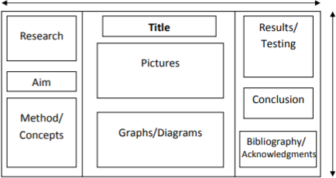

- Always keep a log book that records everything you do—all of your ideas and attempts,
even failed ones. A simple school exercise book does the job fine. Remember to date eve- ry entry as well.
- If your project involves animals, you should be aware of the health and safety guidelines. You will need to ask for special approval if you plan on bringing in any animals.
- If your project involves people, you need to prepare an information sheet to give to the
participants, so that they can be fully informed about the project and what is expected of them. For each participant, you also need to prepare two copies of a consent form (one for them and one for you) for the participant to sign. Parent’s consent will be required.
- Your project doesn’t have to be complicated to win. Keep it simple. You should however be creative and original in your method and design.
- Always include a bibliography!
- Acknowledgements are very important as well. You need to list and thank all the people or organizations who have helped with your project. The judges need to know ho much help
you’ve received in order to avoid unfairness or plagiarism.

When you have finished, check your project against the things the judges will be looking for at the Fair. Can you put ticks against them all?

Criteria | Tick Here
Scientific Method and Understanding (for experiments and innovation)
- Scientific Thought: Clearly defined problem stating hypothesis, plan is effective and completed, variables are adequately controlled, data supports conclusions, background information is adequate.
- Written Report or Log Book: Comprehensiveness of background re-
search, adequate recording of procedures and progress, careful recording of observations, logical conclusions, appropriate applications.
- Skills: skill in using equipment, skill in conducting experiment, skill in data manipulation.
Research (for research projects)
- Level of Research: Based on appropriate research, appropriate level of difficulty, depth of study, complexity of project, degree of completeness, thoroughness of analysis.
- Written Report: Comprehensiveness of background research, organiza- tion of ideas, research of information and content, report presentation
- Skills: A variety or research utilized, references made, new ideas for-
mulated
Depth of Understanding
- Oral presentation and discussion, understanding of concepts used in exhibit, understanding of background knowledge
Originality and Creativity
- Originality of approach or concept, topic selection, choice of medium or
analysis, creative procedure used for solving the problem, resources, ideas, information, innovation and imagination.
Dramatic Value and Clarity
- The layout is logical and self-explanatory
- A concise presentation of information
- An overall nice appearance

Parental Assistance Defined
All projects must be the work of the student; however, parents may assist student with cer- tain aspects of the project. Parental assistance may include the following:
- Parents may help establish the idea of the project.
- Parents may help gather materials.
- Parents may help by answering questions and guiding students through the scientific meth- od.
- Parents may assist with computer-generated word for students.

